Latihan TM10 MBD
Nama: Maulana Ikhsan
NIM: 5025241163
No.1
Sintaks:
CREATE USER admin_toko WITH PASSWORD 'pass123';
CREATE USER admin_album WITH PASSWORD 'pass123';
SELECT usename FROM pg_user;

Hasil:
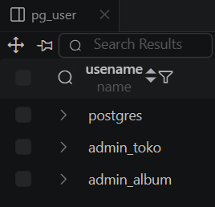
No.2
Sintaks:
-- admin_toko
CREATE ROLE role_toko;
GRANT SELECT, INSERT, UPDATE ON RECEIPT, DETAILITEM TO role_toko;
GRANT SELECT ON SINGER, ALBUM TO role_toko;
GRANT role_toko TO admin_toko;

-- admin_album
CREATE ROLE role_album;
GRANT SELECT, INSERT, UPDATE ON SINGER, ALBUM TO role_album;
GRANT role_album TO admin_album;

-- \du ama \dp

Hasil:
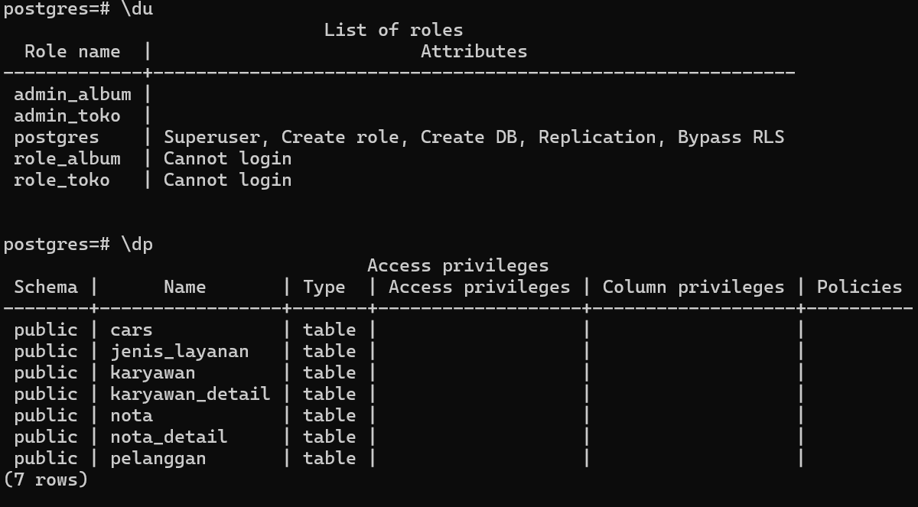

No.3
Sintaks:
